2 Day Jumping Clinic with International Coach and Rider Clayton Fredericks

October 8th & October 9th, 2016

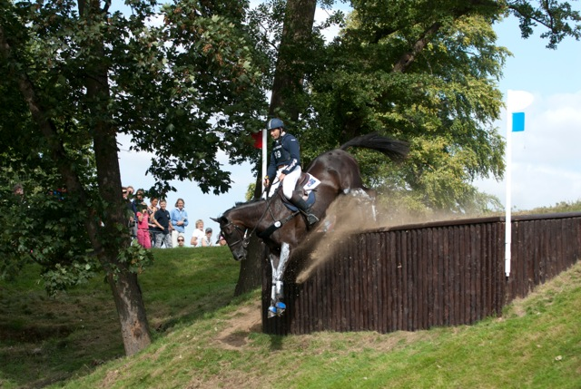
Great prep for the October 2016 Team Challenge Event!!
Clayton Fredericks won Olympic team silver medal in the 2008 Olympic Games and was also a member of the Australian team at the 2012 London Olympic Games. He won an individual silver and team bronze medal at the 2006 FEI World Equestrian Games and won the 2007 Rolex Kentucky CCI4**** event as well as being the FEI World Cup Champion in 2005 and 2008.

Clayton’s international coaching experience extends across all levels of the sport both within leading nations and for less developed countries. In 2013 Clayton was appointed the International Technical Advisor to the Canadian Eventing Team effectively becoming their coach. Now residing in the US, Clayton combines his coaching commitments for Canada with running his Florida Training base where he spends his time producing quality young event horses.

Cost: $395 for both Days
Opening date for Entries: August 20, 2016
Closing Date for Entries: September 20, 2016
Cost Stabling: $25/night Haul-in Fee: $10
All Entries must include current 12 month Coggins
No Refund after Closing Date
All Entries must be COMPLETED and received by Closing Date

